Moustapha Dioume
October 29, 2026
Assignment 2.2
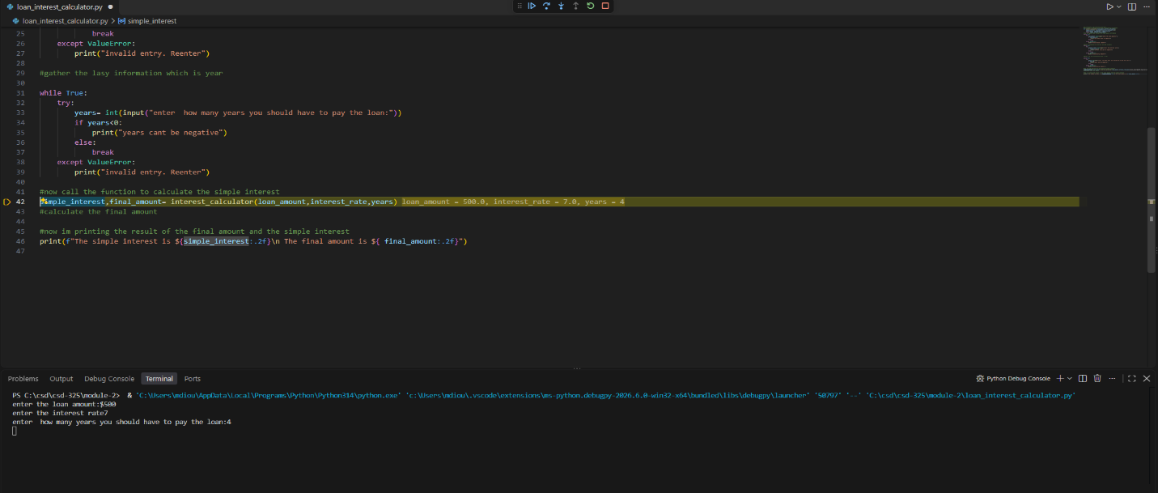
I set up the breakpoint where the function is called.
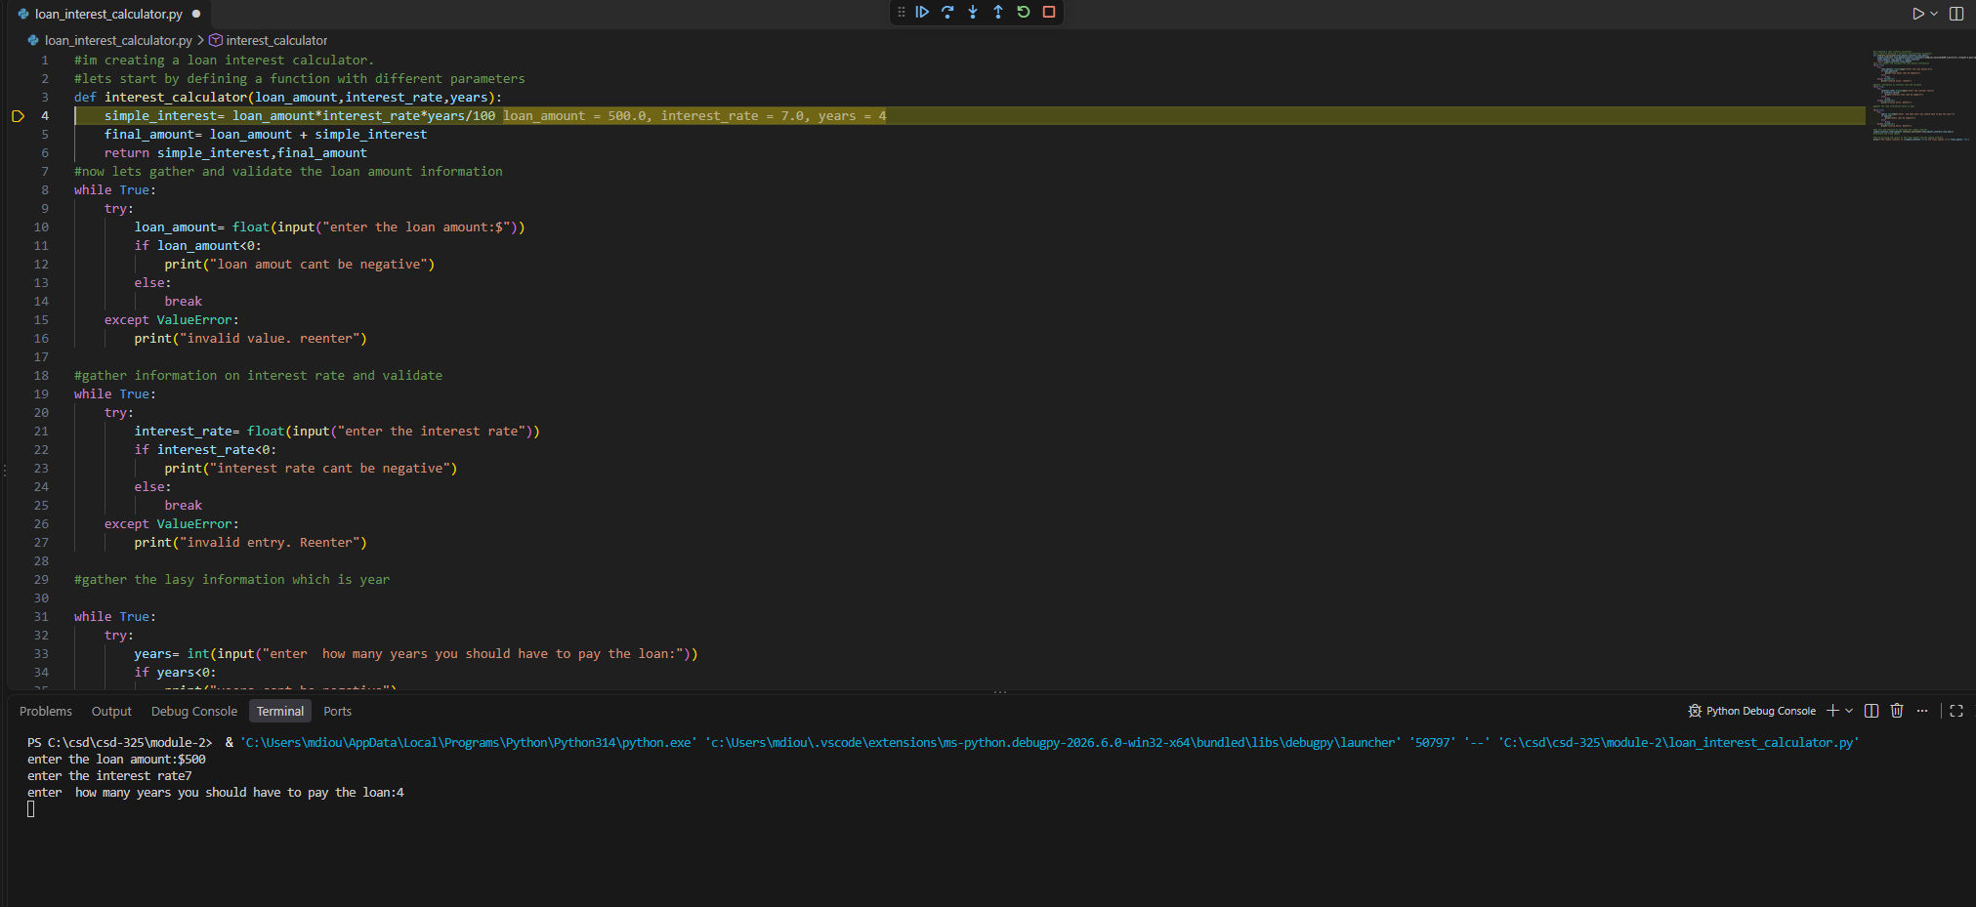
This is where I step into with f (11) to enter my interest calculator function
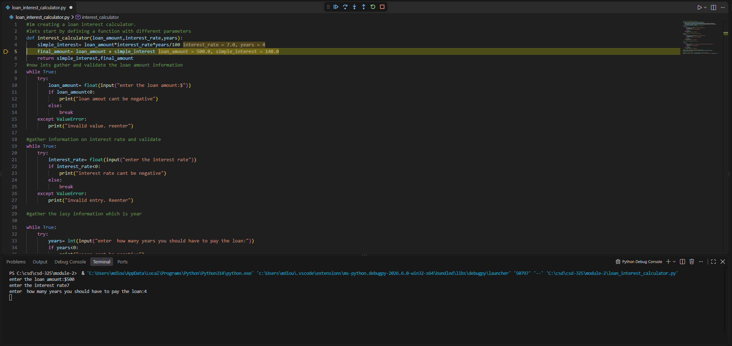
This is when I used f (10) to get the final loan amount value.

